St. Anne's Arts and Science College
Department of Computer Science

Team Members | Register No | Project Name | Phase Topic
PRIYAKA.G | 222409485 | FitTrack AI - Personalized Fitness  Recommendations Powered by AI | Phase 6  PROJECT TESTING
PUSHPA BIBIYA.J | 222409486
REVATHY.V | 222409487
RUBA LATHA.M | 222409488

FitTrack AI
Personalized Fitness Recommendations Powered by AI

PHASE 6
PROJECT TESTING

Project Name: AI FitTrack
Technology: Node.js, Express.js, MongoDB, Mongoose, JWT, bcrypt.js, Google Gemini AI

CONTENTS
6.1 Testing Overview
6.2 Authentication API Testing
6.2.1 User Registration
6.2.2 User Login
6.2.3 User Profile
6.3 Workout API Testing
6.3.1 Add Workout
6.3.2 Get All Workouts
6.3.3 Get Workout by ID
6.3.4 Update Workout
6.3.5 Delete Workout
6.4 AI API Testing
6.4.1 Workout Recommendation Testing
6.4.2 Fitness Insights Testing
6.5 API Response Verification
6.6 Testing Evidence

6.1 Testing Overview
Following the development of the AI FitTrack backend, the implemented RESTful APIs were reviewed through API testing to assess whether the application's principal functions behaved as intended. Postman or Thunder Client may be used to submit requests, inspect responses, and capture testing evidence.
Testing was organized into three functional groups:
- Authentication API Testing
- Workout API Testing
- AI API Testing
Each group was examined in accordance with the operations supported by the backend. The testing descriptions in this phase document identify the intended checks; actual results should be recorded from the test runs and supported by the corresponding screenshots.

6.2 Authentication API Testing
Authentication APIs were considered first because workout operations and other protected endpoints require an authenticated user. The tests cover registration, login, and access to the user profile using an authentication token.

6.2.1 User Registration
The registration endpoint was tested by submitting the required user information. The response was reviewed to determine whether the backend processed the registration request correctly.
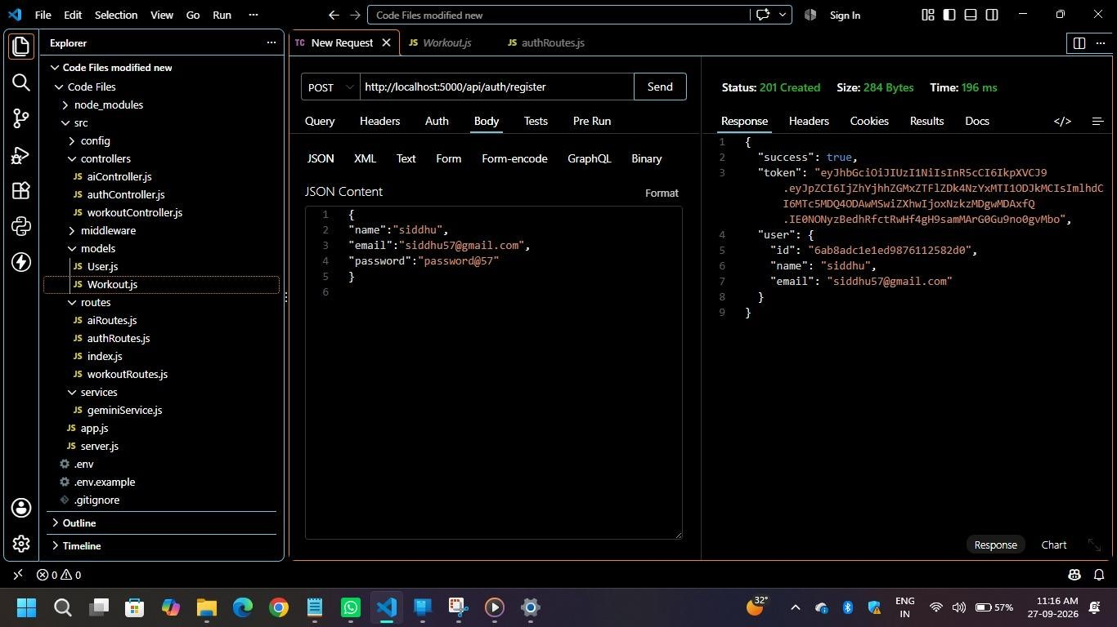
Figure 6.1: User Registration API Test

6.2.2 User Login
The login endpoint was tested with the credentials of a registered user. The response was inspected to verify authentication and the generation of an authentication token.
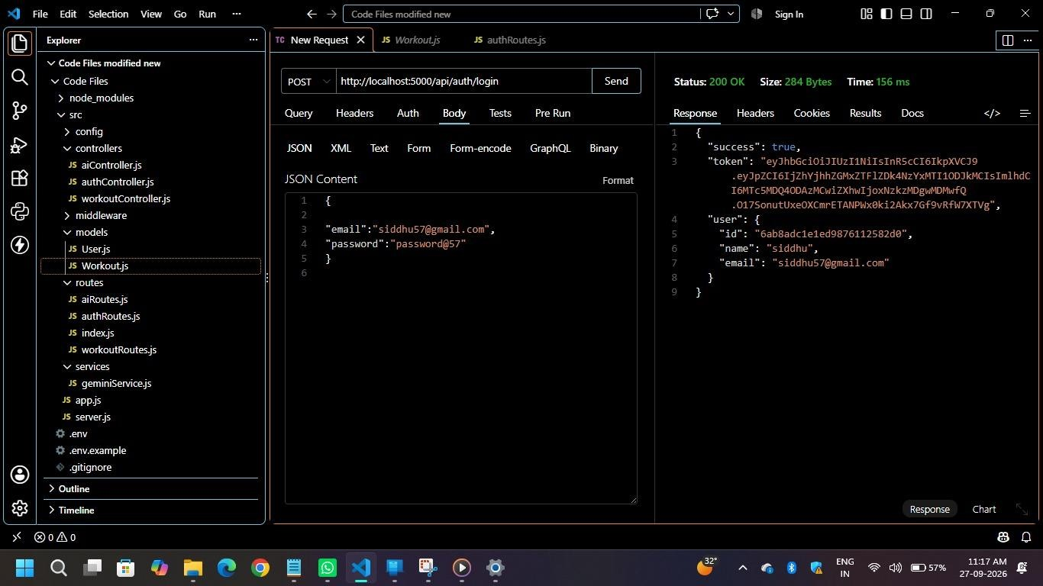
Figure 6.2: User Login API Test

6.2.3 User Profile
The profile endpoint was tested by including the authentication token obtained during login. This check verifies access to a protected user-related endpoint.
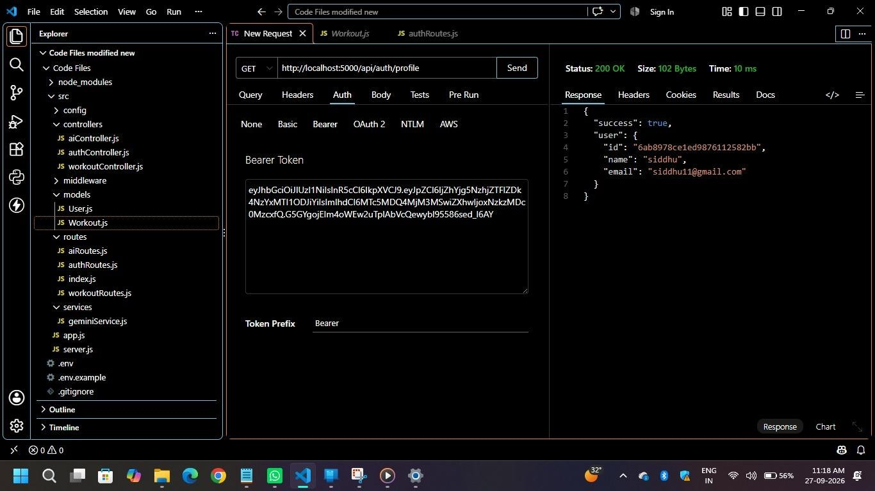
Figure 6.3: User Profile API Test

6.3 Workout API Testing
After the authentication checks, the workout endpoints were tested using an authenticated user. The operations included creating, retrieving, updating, and deleting workout records.

6.3.1 Add Workout
The Add Workout endpoint was tested by submitting the required workout information. The response was examined to confirm that the backend accepted the workout record.
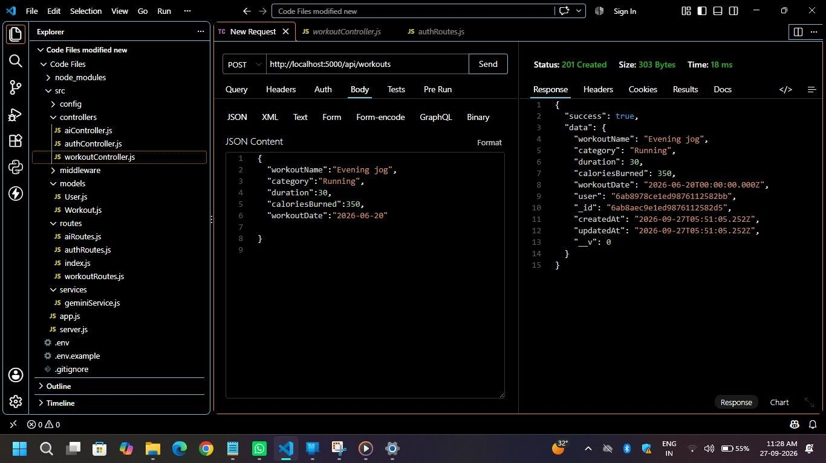
Figure 6.4: Add Workout API Test

6.3.2 Get All Workouts
The Get All Workouts endpoint was tested to verify that workout records belonging to the authenticated user could be retrieved from the database.
Figure 6.5: Get All Workouts API Test
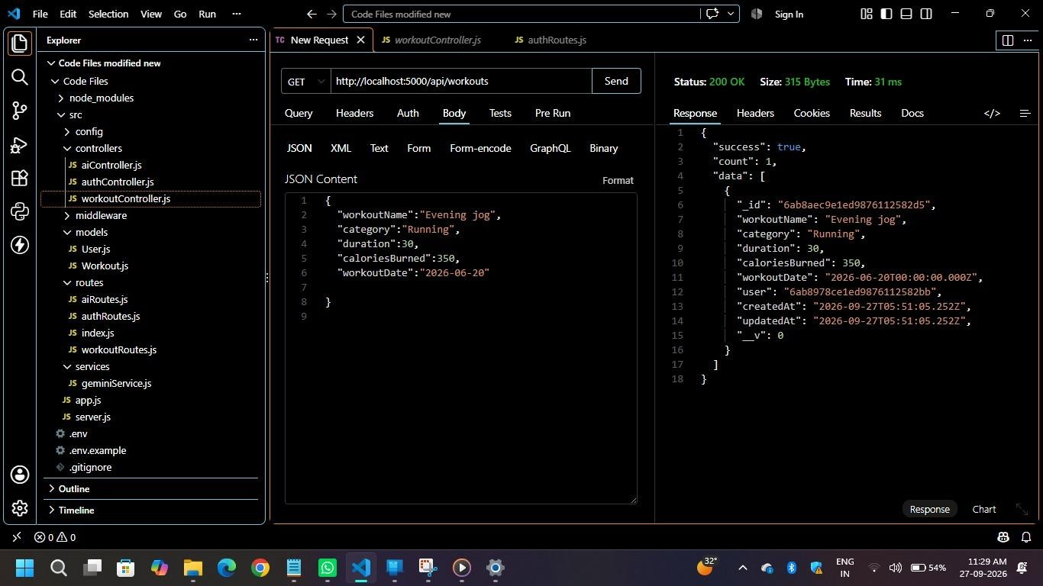

6.3.3 Get Workout by ID
The Get Workout by ID operation was tested by supplying a valid workout identifier and checking whether the corresponding record was returned.
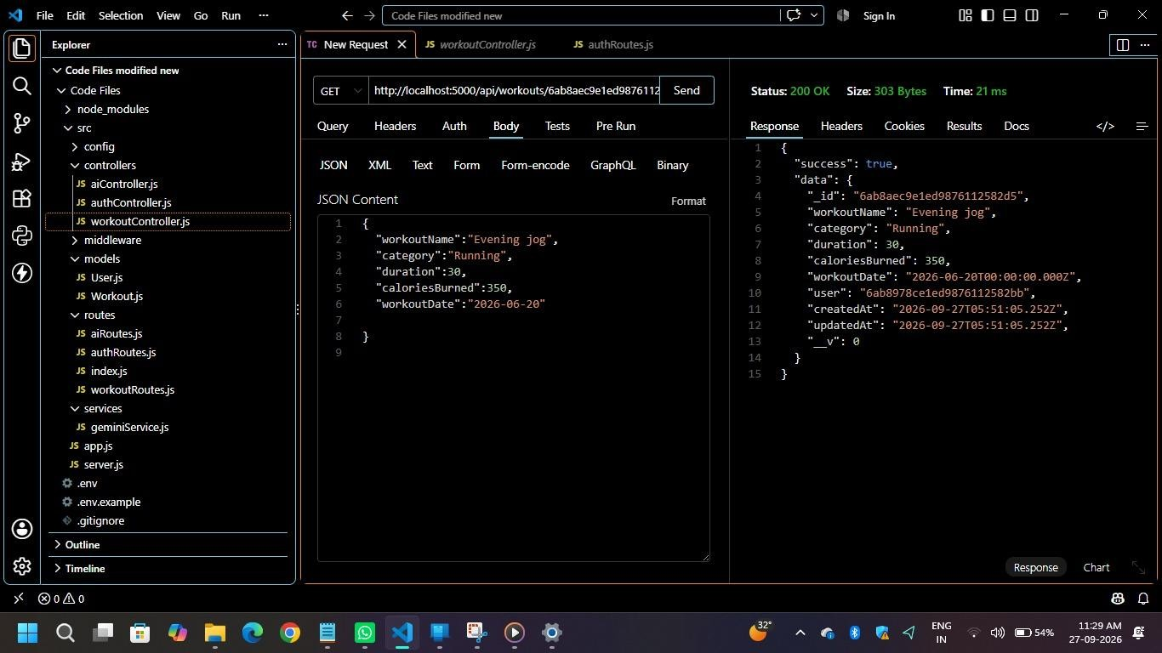
Figure 6.6: Get Workout by ID API Test

6.3.4 Update Workout
The Update Workout endpoint was tested by modifying an existing workout record and reviewing the response returned by the backend.
Figure 6.7: Update Workout API Test
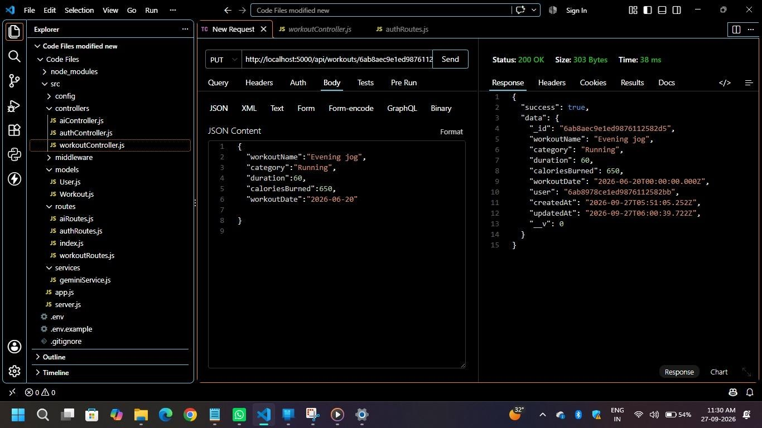

6.3.5 Delete Workout
The Delete Workout endpoint was tested to verify that an existing workout record could be removed.
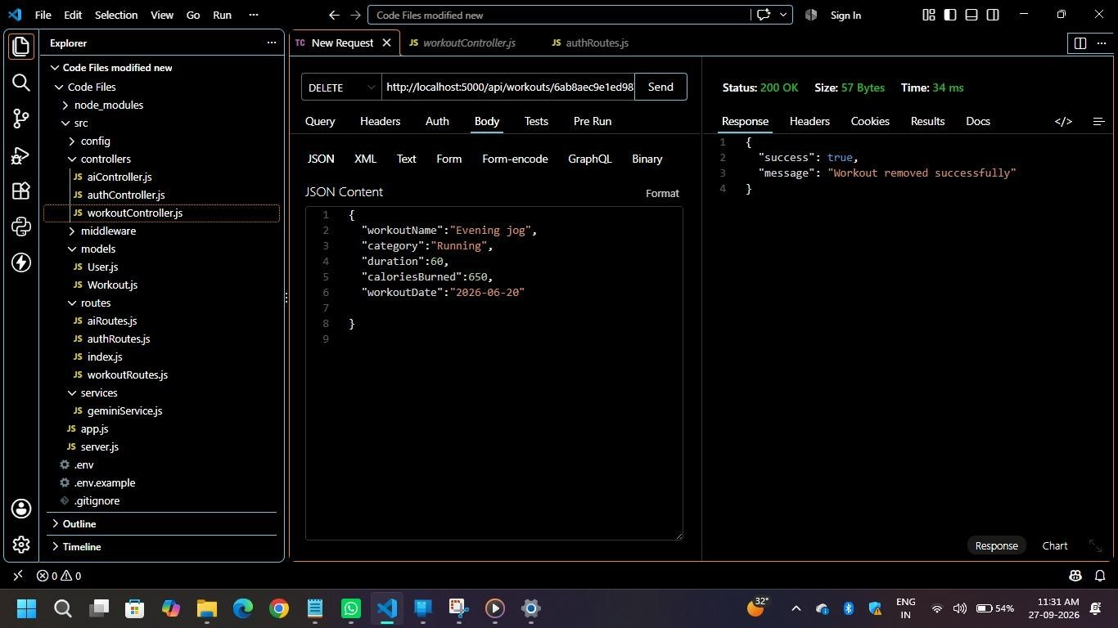
Figure 6.8: Delete Workout API Test

6.4 AI API Testing
The AI-related endpoints were tested after the authentication and workout operations. The two AI functions covered in this phase are workout recommendations and fitness insights.

6.4.1 Workout Recommendation Testing
The Workout Recommendation endpoint was tested by providing the required fitness information. The returned response was examined to assess whether the AI service generated a personalized workout recommendation.
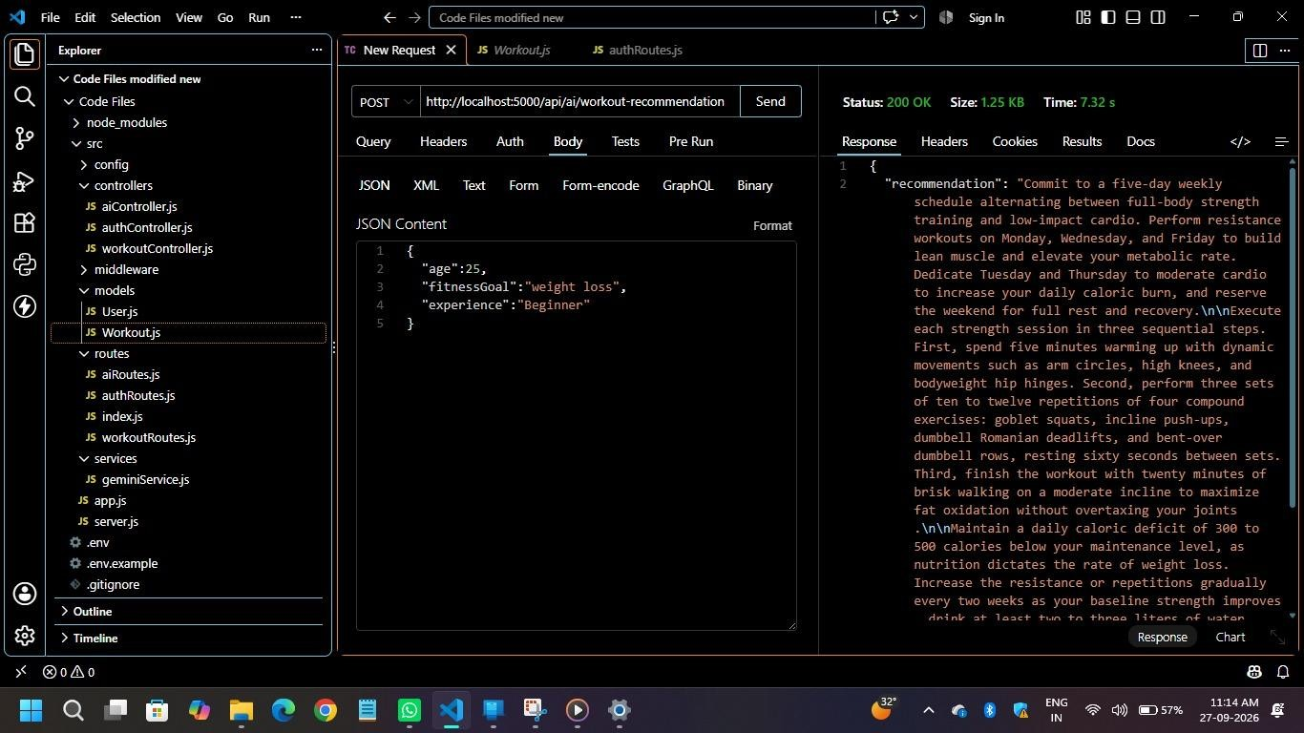
Figure 6.9: AI Workout Recommendation Test

6.4.2 Fitness Insights Testing
The Fitness Insights endpoint was tested using workout-related statistics. The response was reviewed to assess whether the AI service generated fitness-related insights based on the available workout information.
Figure 6.10: AI Fitness Insights Test
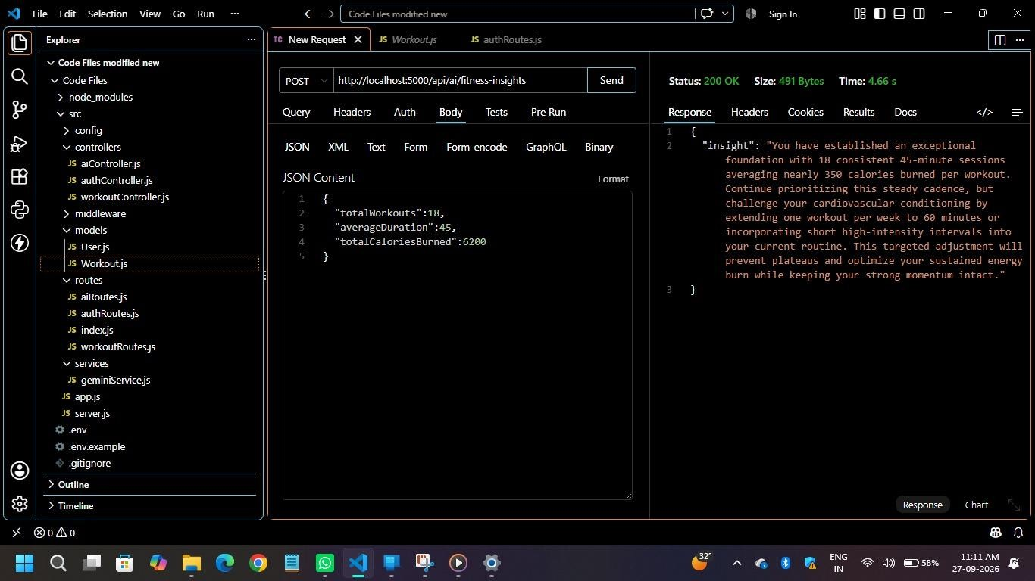

6.5 API Response Verification
During API testing, responses were examined to ensure that requests produced appropriate JSON output. The behavior of protected endpoints was also checked to confirm that authentication is required before access is granted.
For clear and reproducible evidence, each test record should identify the request method and endpoint, relevant input data, response status, and returned response. Any observed result should be documented from the actual test execution rather than assumed.

6.6 Testing Evidence
The testing stage should be supported by screenshots captured from Postman or Thunder Client. Where applicable, screenshots should display the request method, endpoint, input data, response status, and response body. The placeholders below are intentionally retained for insertion of genuine testing evidence.
Figure 6.9: AI Fitness Insights

